-OPERATING SYSTEM DESIGN (5640)
PROJECT-1 REPORT

Understanding of the given project:

The purpose of this project is to implement the semaphore based solution to the problem given, wherein we reflect a system which consists of N storage blocks. Of these N blocks, each can hold one unit information and we considered that unit of information to be integer data type. The created N blocks of storage is initially considered to be empty. We also consider free list to which these blocks are linked. Shared memory is created, so as to be used by all the threads.

Code description:

Shared memory is created, for the different threads to access. We created “mem_block” with 10 blocks of storage of integer data type. Also, we created a structure named “struct” to access the shared variables among the different threads. We used 7 semaphores for mutual exclusion and synchronization purpose among threads, of which three are used for the mutual exclusion, other three are used for count synchronization and the seventh semaphore is used for maximum concurrency.

Firstly, we created empty memory blocks and store the address of these memory blocks in “free list”. Then, list1 and list 2 are created as empty lists. Later, using pthread_create command we create thread1, thread2, thread3 and if thread is not created then print “Error code” and if threads are created then corresponding thread is called when it is created and finally we exit the thread operations.

After thread1, we introduce semaphore called “sem_wait (count_free)”, “sem_wait (sem_free)” to make P operation on freelist count value and freelist respectively so that, shared variable “freelist “cannot be accessed by other threads as well as the count value. Now we unlink the block “b” from freelist by assigning freelist value to pointer variable “b” and make freelist[i]=0 for particular “I” value. Then, we make V operation on “sem_free” semaphore to give access freelist to other threads and we produced a random value into block “b” by using rand function. Now we check if the list1 is empty or not, if it is empty then we link block “b” to particular block of list1.

For thread-2, we introduce semaphore called “sem_wait (count_list1)”, “sem_wait (sem_list1)” to make P operation on count_list1 and sem_list1 respectively so that, list1 is not accessed by other threads. x is unlinked from list1. Then, V is done on list1 followed by P done on count_free and sem_free. y is unlinked from freelist. Semaphore is posted for both sem_free and l1_cont. In order to produce y, we use x i.e., *y=*x+(rand()%10),P is done on sem_free. Thread2 block is inserted in freelist. v is done on sem_free and count_free
. and sem_wait on sem_list2.Thread2 block is inserted in list2 and the semaphores sem_list2 and count_list2 are released.

Finally, in the last thread: count_list2 and sem_list2 are waited, until this thread releases those semaphore, list2 is unlinked and stored in c. And finally, the information present in c is consumed.

Pseudocode:

freelist, list1, list2, Block_size;
sem_free, sem_list1, sem_list2;
count_free, count_list1, count_list2;
sem_l1con;

Thread-1:

var b: pointer to type block;
while true
begin
P(l1_con);
P(count_free);
P(sem_free);
b:= unlink(freelist);
v(sem_free);
produce_information_in_block(b);
p(sem_list1);
link (b, list1);
v(sem_list1);
v(count_list1);
end;

Thread-2:
Var x, y: pointer to type block;
While true
Begin
p(count_list1);
p(sem_list1);
x:=unlink(list-1);
v(sem_list1);
p(count_free);
p(sem_list1);
y:=unlink(freelist);
v(sem_free);
v(sem_l1con);
use_block_x_to_produce info_in_y(x, y);
p(sem_free);
link(x, freelist);
v(sem_free);
v(count_free);
p(sem_list2);
link(y, list-2);
v(sem_list2);
v(count_list2);
end

Thread-3
var c: pointer to type block;
while true
Begin
P(count_list2);
P(sem_list2);
c:=unlink(list-2);
v(sem_list2);
consume_information_in_block(c);
p(sem_free);
link(c, freelist);
v(sem_free);
v(count_free);
end

Headerfile description:

#include <stdio.h>: Tells the compiler to include this header file for compilation.

#include <semaphore.h>: defines the sem_t type, used in performing semaphore operations.

#include <stdlib.h>: defines four variable types, several macros, and various functions for performing general functions.

#include <unistd.h>: header defines miscellaneous symbolic constants and types, and declares miscellaneous functions. The contents of this header

#include <fcntl.h>: define the following requests and arguments for use by the functions fctnl() and open().

#include <sys/types.h>: includes the definitions for all blocks as well as the ones related to threads.
https://en.wikipedia.org/wiki/Mutual_exclusion
#include <sys/shm.h>(shared memory facility): Defines the symbolic constants and structure.
#include <pthread.h>: includes the thread related header files in the program.

CONCEPTS RELATED:

CRITICAL SECTION:

In concurrent accesses to shared resources can lead to unexpected or erroneous behavior so parts of the program where the shared resource is accessed is protected. This protected section is the critical section. It cannot be executed by more than one process. Typically, the critical section accesses a shared resource, such as a data structure, a peripheral device, or a network connection, that does not allow multiple concurrent accesses.
A critical section will usually terminate in finite time,^{[2]} and a thread, task, or process will have to wait for a fixed time to enter it. To ensure exclusive use of critical sections some synchronization mechanism is required at the entry and exit of the program.
Critical section is a piece of a program that requires mutual exclusion of access

MUTUAL EXCLUSION:

Mutual exclusion is a property of concurrency control, which is instituted for preventing race conditions; it is the requirement that one thread of execution never enter its critical section at the same time that another concurrent thread of execution enters its own critical section.
On uniprocessor systems, the simplest solution to achieve mutual exclusion is to disable interrupt during a process's critical section. This will prevent any interrupt service routines from running.
Although this solution is effective, it leads to many problems. If a critical section is long, then the system clock will drift every time a critical section is executed because the timer interrupt is no longer serviced, so tracking time is impossible during the critical section. Also, if a process halts during its critical section, control will never be returned to another process, effectively halting the entire system. A more elegant method for achieving mutual exclusion is the busy_wait.

SEMAPHORES:
A semaphore is a variable or abstract data type that is used to control access to a common resource by multiple processes in a concurrent system such as a multiprogramming operating system. When used to control access to a pool of resources, a semaphore tracks only how many resources are free; it does not keep track of which of the resources are free. Some other mechanism (possibly involving more semaphores) may be required to select a particular free resource.
The paradigm is especially powerful because the semaphore count may serve as a useful trigger for several different actions. The librarian above may turn the lights off in the study hall when there are no students remaining, or may place a sign that says the rooms are very busy when most of the rooms are occupied.
Semaphores are of two types −
- Binary semaphore
- Counting semaphore
Binary semaphore can take the value 0 & 1 only. Counting semaphore can take nonnegative integer values.
Two standard operations, wait and signal are defined on the semaphore. Entry to the critical section is controlled by the wait operation and exit from a critical region is taken care by signal operation. The wait, signal operations are also called P and V operations. The manipulation of semaphore (S) takes place as following:
- The wait command P(S) decrements the semaphore value by 1. If the resulting value becomes negative, then P command is delayed until the condition is satisfied.
- The V(S) i.e. signals operation increments the semaphore value by 1.

DEADLOCKS:

In concurrent computing, a deadlock is a state in which each member of a group of actions, is waiting for some other member to release a lock. Deadlock is a common problem in multiprocessing systems, parallel computing, and distributed systems, where software and hardware locks are used to handle shared resources and implement process synchronization.
In an operating system, a deadlock occurs when a process or thread enters a waiting state because a requested system resource is held by another waiting process, which in turn is waiting for another resource held by another waiting process. If a process is unable to change its state indefinitely because the resources requested by it are being used by another waiting process, then the system is said to be in a deadlock

OUPUT:

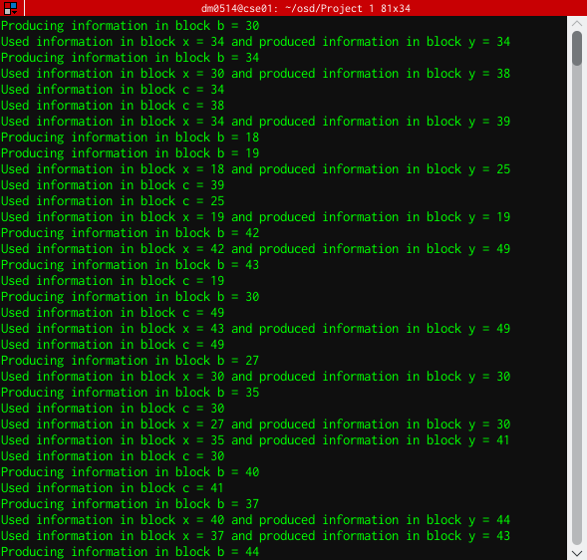

NOTE:

Please compile with the following command: -w gcc -pthread (code.c)

References:
[1]. Beginning Linux Programming by Richard stones and Neil Matthew.
[2]. Operating System Concepts by Silberschatz, Galvin, Gagne.
[3]. Modern Operating Systems by Andrew S. Tanenbaum.
Web Resources:
1. https://www.tutorialspoint.com/
2. https://en.wikipedia.org/wiki/Semaphore_(programming)
3. https://computing.llnl.gov/tutorials/pthreads/
Referred other web resources for syntax's and example code.

